Example assurance plan
A simple Agile assurance plan for New Zealand government digital projects
The plan is based on the government assurance plan template, and our Agile assurance guide. It may help to read the guide before you start your plan.
The example is for a non-specific public-facing web application. It shows the type of information you’d include, not the detailed information itself.
To complete the plan, replace or delete the <explanatory text>.

<Investment name>:

Assurance plan
[Version number]

[Date]

Document control
Revision history
Version | Date | Author | Description of changes
1.0
Reviewer list
<The reviewer list should include all factual accuracy reviewers, programme/project manager and Internal Audit.>
Name | Title | Business group
Document approval
The assurance plan is endorsed by:
<Signature> | <insert governance body name> | Date
<Signature> | <insert key stakeholder name> | Date
Senior Responsible Owner
I have reviewed the assurance plan and confirm that it is fit-for-purpose based on my understanding of the complexity and risk of the investment.
<Signature> | <insert SRO name> | Date

Contents
1 Investment overview 1
1.1 Objectives and outcomes 1
1.2 Structure 1
1.3 Risk rating 1
1.4 Referenced documents 1
2 Assurance plan overview 2
2.1 Assurance approach 2
2.2 Lessons learned 2
2.3 Key risks 2
2.4 Plan on a page 2
3 Detailed assurance plan 3
3.1 Independent assurance 3
3.2 Governance and oversight 3
4 Assurance roles and responsibilities 4
4.1 Governance structure 4
4.2 Assurance roles and responsibilities 4

Investment overview

Objectives and outcomes
<Include an overview of the investment objectives and outcomes being sought. This should include alignment to any strategic, sector or All-of-Government outcomes and agreed success criteria.>
- Vision
- Strategy and target users
- Key metrics

Structure
<Include an overview of the structure of the investment (is this a portfolio, programme or project and what methodology is being applied). Include any tranches/phases/projects and any financial implications/funding structures/funding decision points i.e. delivery of Phase 1 will enable release of Cabinet funding allocation for Phase 2.>
This is Project B. It follows on from Project A. It will use the Scrum methodology.

Risk rating
<Insert Treasury’s risk rating based on the Risk Profile Assessment.>
Risk Rating from Risk Profile Assessment (RPA)
N/A — This assumes the project isn’t high-risk because you’ve de-risked it when you developed your business case. Get guidance on how to develop low-risk government business cases.

Referenced documents
Document | Version
<Include all reference documents which should be read in conjunction with the assurance plan>
Link to digital version of the backlog
Discovery deliverables
Governance Terms of Reference (TOR)
Independent review TOR(s)
Definition of done (DoD)
Maintenance plan
Statement of Work

Assurance plan overview

Assurance approach
<Include an overview of the assurance objectives, scope and approach. It is expected that the assurance plan will cover the current delivery phase but may not include detailed assurance activities in subsequent phases. Note the date the assurance plan will be next reviewed and updated.>
The project will use Scrum methodology to provide assurance that we deliver the outcomes noted above.
Working software will be the primary measure of progress. We will demo the latest iteration at the review at the end of each two-week sprint. Work will only be considered complete if it meets the quality standards in our definition of done. User testing and other user research will assess how well the software delivers the planned user benefits. Learnings from the user research and feedback from the review will be used to prioritise work for the sprint ahead. Budget and time remaining will be tracked.

Lessons learned
<Outline any specific lessons learned from similar initiatives (either internally or publicly available) and how you have incorporated these into your assurance approach.>
Lessons learned from previous project A:
- Actions from retrospectives
- Discovery deliverables
- User research insights
- Techniques that helped people involved in assurance understand and use the Scrum framework effectively

Key risks
<Include key strategic and delivery risks for the investment. Alternatively, provide a copy of your risk register as an appendix to the assurance plan.>
Failure to deliver on time, on budget and to acceptable quality will mean the planned user benefits will remain unrealised.
Potential points of failure include:
- User needs assumption A
- New technology B
- Lack of Agile experience for independent reviewer C
- Fixed deadline D

Plan on a page
<Include a high level overview of the key assurance activities (‘plan on a page’) showing:
- Key decision points (including stage gates)
- Assurance activities that support the key decision points.
There should be a clear relationship between the assurance activities in the detailed assurance plan and how these relate to the key decision points. It is expected that the plan on a page will cover the key decision points for the current delivery phase and may not include detailed information on subsequent phases.>
Assurance stage gate:
- SRO signs off on this assurance plan
Discovery stage gate:
- SRO signs off on the vision, strategy and Minimum Viable Product (MVP)
Integration of work into the increment:
- Product owner acceptance
- Meets Definition of done
Prototype stage gate:
- Prototype user testing: key task completion within tolerance
Go live stage gate:
- MVP user testing: key task completion within tolerance
- Independent reviews passed
- Maintenance plan accepted

Detailed assurance plan

Independent assurance
<Include internal audit reviews; third party assurance reviews, including Independent Quality Assurance (IQA) and Technical Quality Assurance (TQA) reviews; quantitative risk analysis; and Gateway reviews.>
Internal:
- CISO sign off
- Architecture group sign off
External:
- Security reviews
  - Penetration Testing
  - Security Risk Assessment
  - Controls Validation Audit
- Privacy Impact Assessment
- Government web standards assessment

Governance and oversight
< Include regular governance and oversight activities e.g. governance meetings, executive project status reports, Audit and Risk Committee oversight; health checks performed by an internal EPMO; and risk reviews performed by an internal Risk function>
- Review: Every two weeks
- SRO meeting with the product owner: Every week
- Governance group meeting schedule: Every two months
- Time and budget reports: Every two weeks
- User research reports: As completed

Assurance roles and responsibilities

Governance structure
<Include a diagram of the governance structure for the investment.>
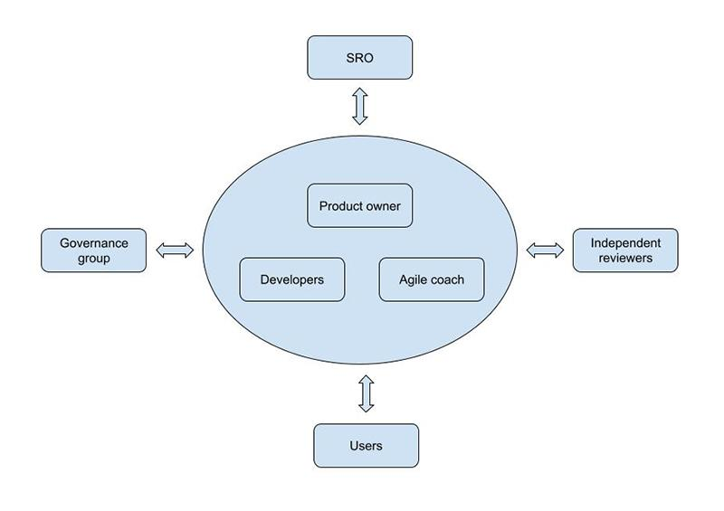

Assurance roles and responsibilities
<Describe assurance roles and responsibilities. For example:
- Who will review and approve key assurance artefacts (e.g. assurance plans, terms of reference and assurance reports)?
- How will progress against the assurance plan be monitored at the governance level?
- Who will receive copies of assurance reports?
- How will the status of issues raised in assurance reports be tracked and reported at the governance level?>
- SRO reviews and accepts the assurance plan, discovery deliverables and assurance reports
- Product owner reviews and accepts the DoD
- Product owner reviews and accepts individual user stories
- All governance group members and independent reviewers can attend reviews
- Product owner and SRO to receive user research, time and budget reports
- Governance group to receive discovery deliverables and user research reports
- Any member of the Agile delivery team, governance group or independent reviewers can raise issues with the product owner at any time (and the product owner can raise issues with the Agile coach)

